**Project Design Phase-II**

**Data Flow Diagram & User Stories**

|  |  |
| --- | --- |
| Date | 15 October 2022 |
| Team Id | PNT2022TMID10587 |
| Project Name | Project – Skill and Job Recommender |
| Maximum Marks | 4 Marks |

**Data Flow Diagrams:**

A Data Flow Diagram (DFD) is a traditional visual representation of the information flows within a system. A neat and clear DFD can depict the right amount of the system requirement graphically. It shows how data enters and leaves the system, what changes the information, and where data is stored.

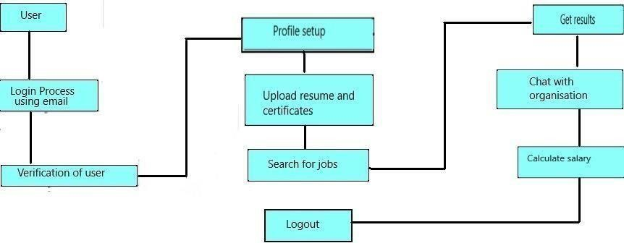

**User Stories**

|  |  |  |  |  |  |  |
| --- | --- | --- | --- | --- | --- | --- |
| **User Type** | **Functional**  **Requirement (Epic)** | **User Story**  **Number** | **User Story / Task** | **Acceptance criteria** | **Priority** | **Release** |
| Customer  (Mobile user) | Registration | USN-1 | As a user, I can register for the application by entering my email, password, and confirming my password. | I can access my account / dashboard | High | Sprint-1 |
|  |  | USN-2 | As a user, I will receive confirmation email once I have registered for the application. | I can receive confirmation email & click confirm | High | Sprint-1 |
|  |  | USN-3 | As a user, I can register for the application through Facebook. | I can register & access the dashboard with Facebook Login | Low | Sprint-2 |
|  |  | USN-4 | As a user, I can register for the application through Gmail. |  | Medium | Sprint-1 |
|  | Login | USN-5 | As a user, I can log into the application by entering email & password. |  | High | Sprint-1 |
|  | Dashboard | USN-5 | As a user, I can access my dashboard after signing in. | I can access my account / dashboard | High | Sprint-1 |
| Customer (Web user) | Access | USN-6 | As a user, I can setup a profile, and basic details by signing in. |  |  |  |
|  |  | USN-7 | As a user, I will upload my resume, certificates, and other requirements. | I can perform several task in the application | Medium | Sprint-1 |
| Customer Care Executive | Chatbot | USN-8 | As a user, I can seek guidance from the customer care executive. |  | High | Sprint-1 |
| Administrator | DBMS | USN-9 | As a administrator, I can keep the applications of your organization relies on running. | I can perform various modifications in the applications. | High | Sprint-1 |